Chapter 4: Analysis data and Evaluation
- Overview
The chapter is to analyze and evaluate data collect from the research conducted in chapter 3. With the analysis and evaluation conducted in this chapter, we will provide the final answer about how Google Digital Wellbeing improve the life of people who addict to their smart phone. To optimize the analysis and evaluation, we also provide several graphs to illustrate the answers.
- Analysis data
  - Survey data analysis
- Question 1
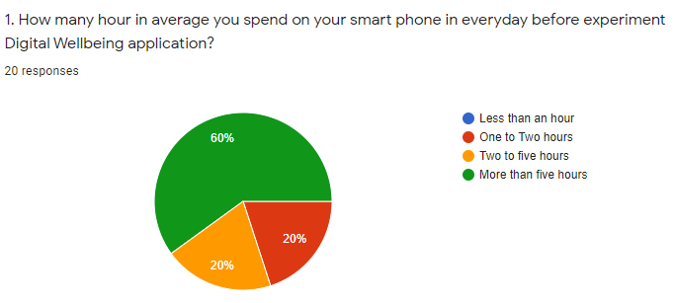
Figure 1 : Summary of answer of question 1
According to the summary of answer of question 1, we can conclude that most of volunteers spend large amount of their time on smart phone. In the chart, 60% of answers are more than five hours, and 20% are two to five hours. Thus, we can see that about 80% of them spend at least more than two hours which is not really healthy. On the other hand, only 20% volunteer are less than two hours, but, unfortunately, none of them spend less than an hour on their phone. Consequently, the result can give us the fact that these are big numbers of people spend two to five hours or even more on smart phone.
- Question 2
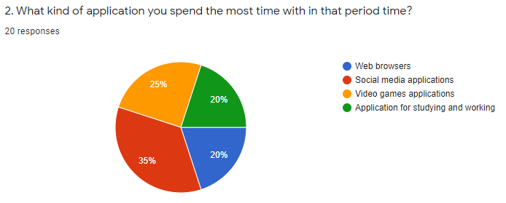
Figure 2 : Summary of answer of question 2
According to the summary of answer of question 2, we can see that about most of volunteers, who are spending a lot of their time on smart phone, are not use their phone for study or work. The chart point out that 35% volunteer spend their time on social media apps, 25% spend on videos game, and 20% are on web browser. Thus, we can sum up that about 80% of them on unhealthy application. On the other hand, the percent of people using phone on study and work is only 20%. Significantly, with the result, we can state that most of smart phone users are addicted on unhealthy smart phone applications.
- Question 3
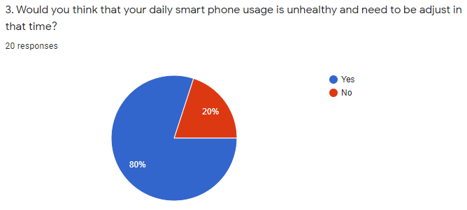
Figure 3 : Summary of answer of question 3
With the answers of question 3 , we can see that most of volunteers realize their behavior on smart phone is unhealthy and need to be changed. According to the chart, we have 80% of volunteers admit their unhealthy usage. However, these still have 20% of them consider that their behavior is not unhealthy. As a result, we can see that people addicting smart phone start to consider about their unhealthy behavior and want for the change.
- Question 4
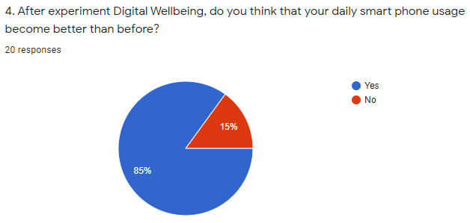
Figure 4 : Summary of answer of question 4
According to the summary, most of volunteer think that their behavior on smart phone become better. The chart show that 85% of volunteers answers choose yes, and only about 15% choose no. Consequently, we can state that most of people think that Google Digital Wellbeing can change them to become healthier, however, it may still can not help some of people.
- Question 5
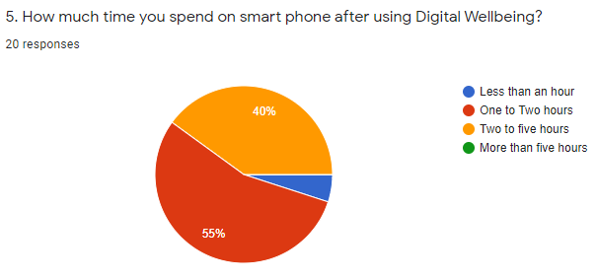
Figure 5 : Summary of answer of question 5
With the summary, we can state that Google Digital Wellbeing is quite efficient on reduce the time volunteer spend on smart phone. In the summary of answer of question 1, we have 60% of volunteer choose more than five hours, 20% choose two to five hours, 20% are less than two hours, and none of them spend less than an hour. However, after experiment Google Digital Wellbeing, the volunteers have provide a completely different answers. In the summery of question 5 answers, these are 55% of answers choose one to two hours, 40% choose two to five hours.
5% choose less than an hours, and surprisingly no volunteer choose more than 5 hours. Comparing the summary of answers of question 1 and 5, significantly, Google Digital Wellbeing efficiently reduce large amount of time of users spending on their phone.
- Question 6
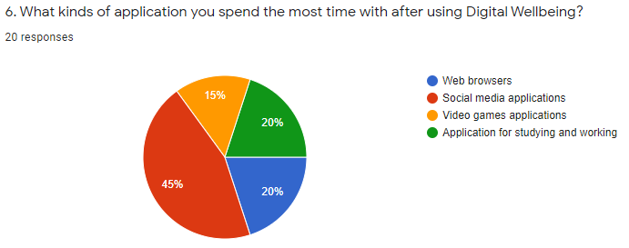
Figure 6 : Summary of answer of question 6
According to the summary of question 6 answers, we see that Google Digital Wellbeing is not good at completely prevent users from using unhealthy applications. In the summary of question 2, 35% of volunteer spend most time on social media applications, 25% spend on videos game, and 20% are on web browser, only 20% people using phone on study and work. Similarly , In the summary of question 6, 45% of volunteers choose social media applications, 20% are Web browsers, 15% are videos game applications, and 20% are application for study and work. Significantly, the answers of two question are quite similar, the application spend most time with of people do not change, only 10% of them change from videos game to social media applications. Thus, we can conclude that Google Digital can not efficiently prevent people focus on unhealthy applications.
- Question 7
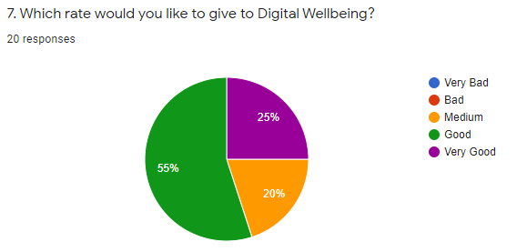
Figure 7 : Summary of answer of question 7
With the summary of question 7, we can see that the rate of Google Digital Wellbeing is quite good. In the chart 55% of answers are good, 25% are very good, and 20% are medium. If we change the rate to points, for example, very good equal 5 points, good equal 4 points, and so on, we will can calculate the average points of Google Digital Wellbeing. We have 55% (11 people) choose good (4 points), 25% (5 people) choose very good (5 points), and 20% (4 people) choose medium (3 points). And we will have the following calculation to get the average score:
[(11 x 4) + (5 x 5) + (4 * 3)] / 20 = 4.05 points
With the average score, we can conclude Google Digital Wellbeing is the good application in users mind.
- Question 8
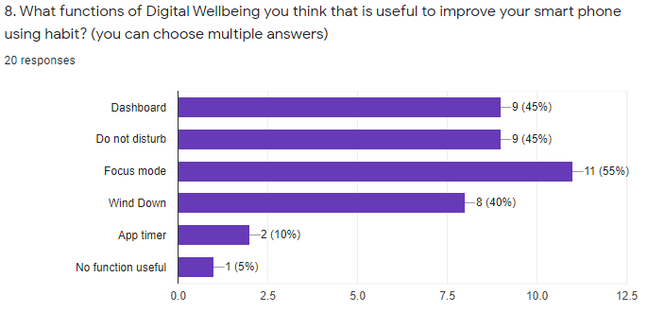
Figure 8 : Summary of answer of question 8
According to the summary answer of question 8, most of functions of Google Digital Wellbeing can help users improving their smart phone using habit. In the chart, we see that 11 people choose focus mode, 9 people choose dashboard, 9 people choose do not disturb, 8 people choose Wind Down, 2 people choose App timer useful, and only 1 people think not any of function useful. With the result of the chart, we can see that most of Digital Wellbeing features are useful. However, App timer is quite not useful in volunteers opinion.
- Question 9
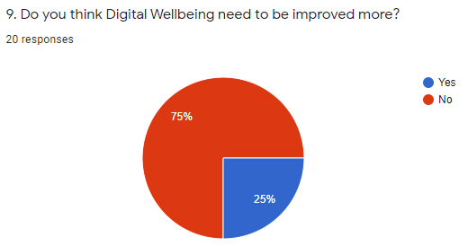
Figure 9 : Summary of answer of question 9
With the answers of question 9, we see that most of users do not think it need to be improved. According to the chart, we have 75% of volunteers think it is good enough and not necessary for improvement. However, remaining 25% of them think it still need to be improved. Consequently, current version of Google Digital Wellbeing are quite suitable for most of users, but it still have some drawbacks which can not satisfy some of users.
- Question 10
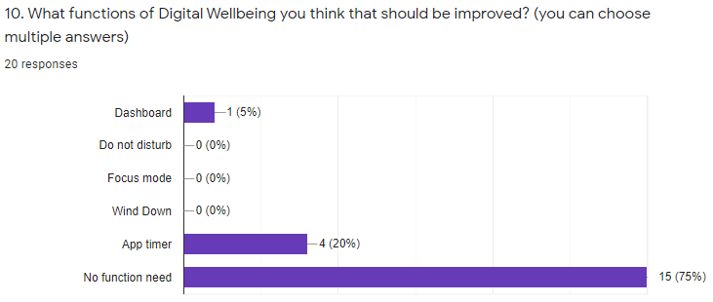
Figure 10 : Summary of answer of question 10
According to the summary, we can see that most of volunteers satisfy with the features and functions of Google Digital Wellbeing, but some of volunteers require the improvement. According to the chart, 15 people think that no need for improvement. However, these are 4 people think app timer and 1 people think Dashboard need to be improved. As a result, except App timer, other functions not necessary for improvement.
  - Interview data analysis
With the data collected from the interview about how Google Digital Wellbeing improve people life, I can state that the majority of smart phone users have the unhealthy life styles. The reason is that most of interviewees spend large amount of time, 3 hours on average, using unhealthy applications such as videos game, social media applications. Only few of them spend with reasonable duration.
The result of survey and interview state that Google Digital Wellbeing efficiently help users adjust their smart phone usage become healthier. After experiment Google Digital Wellbeing, the time users spending on smart phone reduced significantly. Unfortunately, it can not completely help users stop using unhealthy application. But, indirectly, the application improve their aspects of life in a variety of forms, from spending more time on other healthy and meaningful activities. Thus,in the interview, most of Google Digital Wellbeing users have the positive feeling toward the application.
According to the interview data, most of Google Digital Wellbeing features are considered effective. The most mentioned in the interview are Wind Down and Focus mode. Wind Down efficiently on prevent people using smart phone at the late night. Thus, reducing large amount of smart phone using time because most of people like to stick on smart phone at night. Focus mode, on the other hand, help people focus on their task on period of time until the finish their work. The function is claimed are useful to person who do not want to get disturb during their work or study.
Despite of most of Google Digital Wellbeing functions are efficient, these is a functions that are not useful in some of users opinion: App Timer. The reason for the opinion is that the App Timer is not forceful enough to prevent users from using unhealthy application. Because the function can easily be canceled although the timer already set up, it is not quite effectively adjust the smart phone usage, especially to person who addict to videos game and social media applications.
- Evaluation
According to the overall research, we have the following evaluation of Google Digital Wellbeing.
Google Digital Wellbeing is a good application which can greatly help people improve their life. It provides so many features to efficiently modify users behaviors
H
- Conclusion
Fortunately, the research requirements has been met in the end of the research. During the research, we have faced several obstacles which can lead to failure to the research. One of the obstacles is the modification of the objectives of research. as I . However, some how the change of objectives do not lead to large change on the research, thus, the change has been modified to meet the deadline of research. Another obstacle is to conduct interview and survey. Initially, the numbers of volunteers are not meet the requirements. Fortunately, later on, I found some of researcher are researching about Digital Wellbeing, so I asked them for being the volunteers and they accepted. The final obstacles is data analysis, as this is the first analysis research doing on my own. Thus, the time for the data analysis phase is consumed more than I expect. But I still managed to finish the research before deadline although it almost over the deadline. Although I met so many obstacles among the research, the experience I gain from it is very valuable which can provide a lot of help in my future research.

